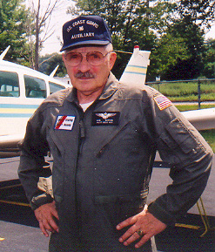
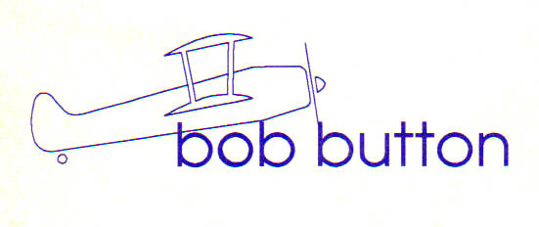

Bob Button is an award-winning writer and journalist and a published author since the age of 12 when his first poem got into print. During subsequent decades he has written for a few daily newspapers, international news syndicates, national magazines, and more recently aviation/space websites. During the Sixties Button was a documentary film writer-director; his films, mostly about America’s man-in-space program, garnered such honors as an Academy Award nomination.
During the Seventies Button’s stories appeared in a dozen national and international aviation publications. His space travel stories have appeared on the covers of such major U. S. magazines as Science Digest and TV Guide.
Button joined the National Aeronautics and Space Administration in 1960 as a public affairs officer during the Mercury, Gemini, and Apollo space programs. Among his many roles during those early man-in-space days was as the “Voice of Gemini,” broadcasting from the Mission Control Center during missions. Between missions Button traveled with the astronauts as their spokesman.
Button also served in every branch of the U. S. military, is a Purple Heart veteran of the Korean War, retired as an Army sergeant major, then flew Search and Rescue for the U. S. Coast Guard Auxiliary for ten years. Since retiring from the Army and NASA, Button has worked as a freelance writer and editor.
-2014-

