# Uploading Files on the Pagoda Writers Cloud

In order to use the shared file structure on the HPL501c3 domain, you can either click on the link available on the organization website, or you can go to:

http://HPL501c3.org/Mollify

## Logging In

Once you get there, you will see the login screen:

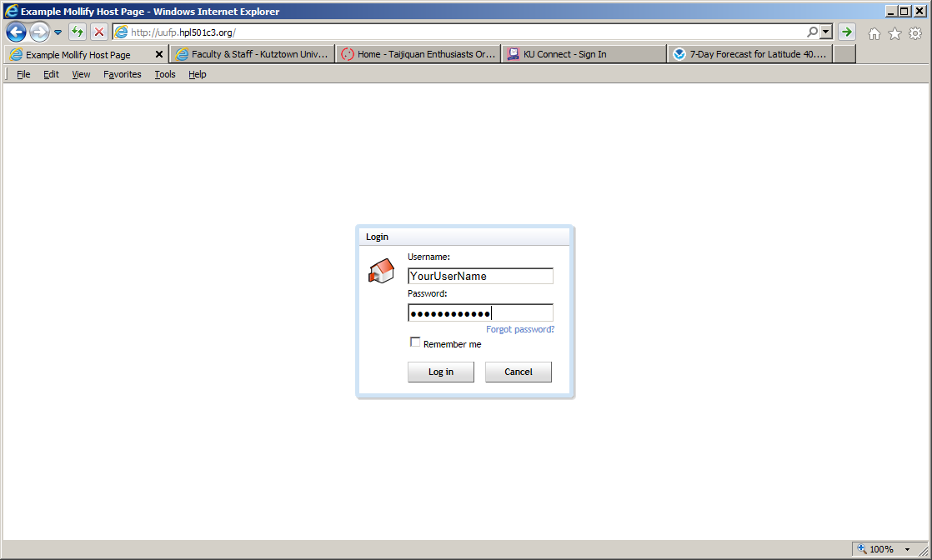

Enter the username and password that you have been given. Some small groups use one username and password for everyone. If that is the case for you, do not click on the **Forgot password?** choice, or you will reset the password for everyone. In that case, contact the group leader to find out what the password is.

Once you've entered your usernamame and password, you will get taken to your groups' cloud (online file storage area).

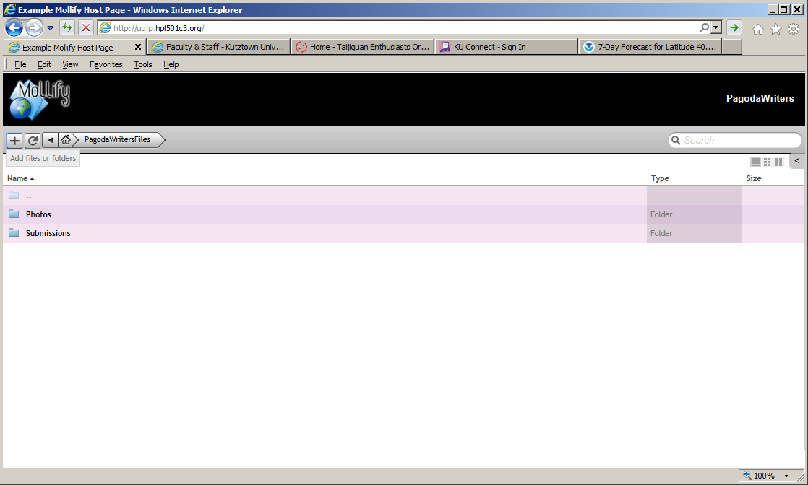

# Using Mollify

## Creating Folders

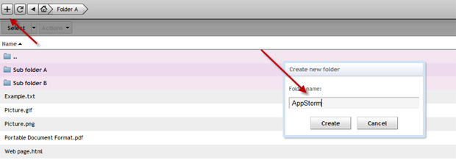

## Adding Folders

Creating folders is easy; use the *+* symbol on the top left corner to do so. Give the folder a name and you’re in business. If you can’t see the folder you’ve created, use the *refresh* button in the app (not the one in the browser) and it will be displayed. You can create as many folders as you want and the navigation is also simple.

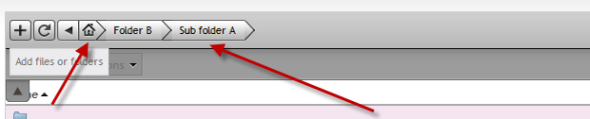

## Navigating through Folders

You can access folders within folders, one after another, the same way you do in Windows explorer or any other desktop file management app. If you’re deep into a lot of folders, use the breadcrumbs at the top to go back to a folder of your choice. Alternatively, hit the *home* button (again, not the one in the browser) to get back to the root folder list.

## Uploading & Accessing Files

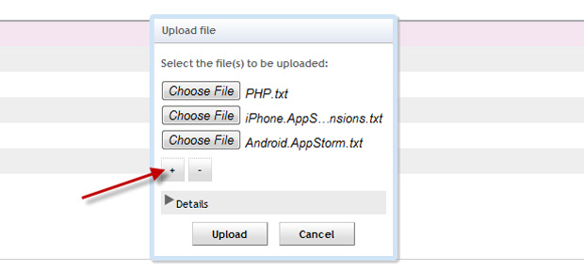

Hit the + icon and this time choose the Add files option to initiate the process. Mollify lets you upload multiple files in one go. Add as may as you like and they will find their way into your server. You can upload all types of files.

## Downloading the files

Click on the folder itself to open it and see the files inside.

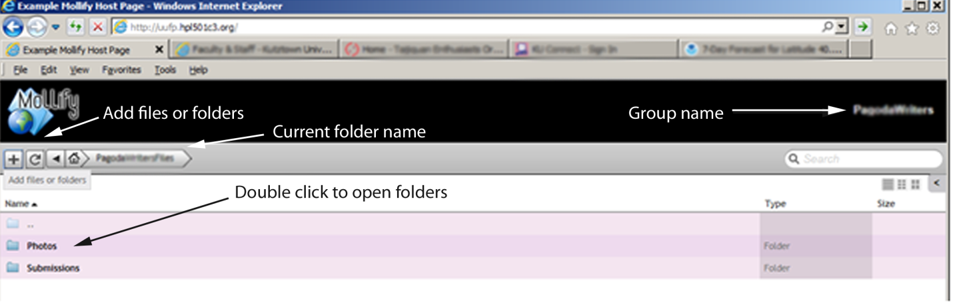

Once you see the files, if you hover over them you will notice an option triangle appear to the right of the filename. The options will allow you to move or copy the file, but not download it. To download the file you must actually click on the filename, and then you will get the Download button.

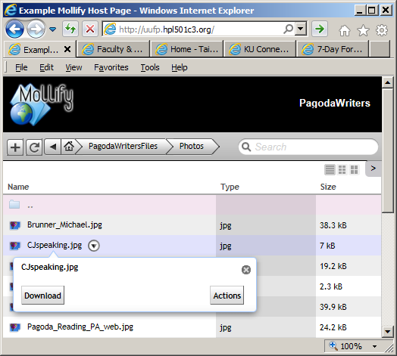

Once you click download, you may get another dialog box that will allow you to save the file to a particular location on your system. (This option depends upon your system. If you have not configured your browser to let you choose the file location for downloads, then the file will simply download into your default download folder with the same name as it was listed on the cloud file storage area.)

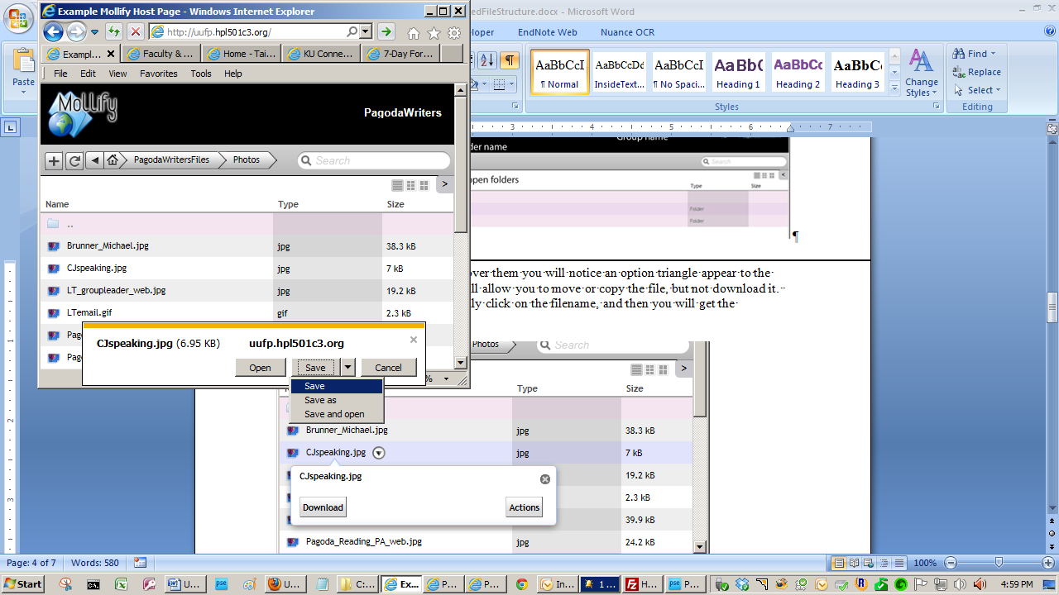

## Using the Dropbox

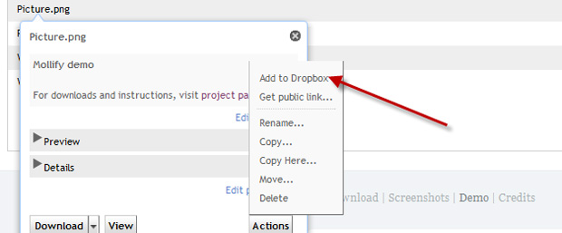

## Adding to Dropbox

Mollify has a built in *dropbox*. This feature has no connection with the popular file syncing service Dropbox. If you plan to download multiple files from multiple folders, you don’t have to download files one after another. Instead, select them and move them to the dropbox.

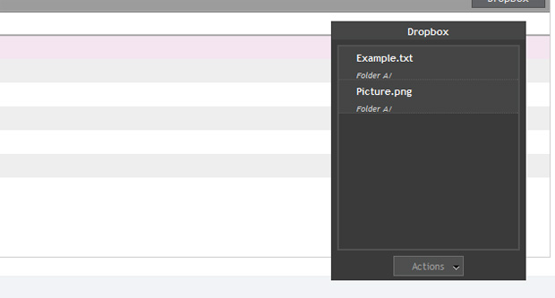

## Dropbox View

Consider the dropbox feature of Mollify to be like that of a shopping cart. Once you’ve moved all the files to the dropbox, you’re done and will be able to download them all in a single zipped archive by going to the menu marked *dropbox* on the top left corner.

# Managing Users

Some people within each organization have the ability to create new users and delete old users. If you do have rights, click on the group name in the upper right corner, and choose **administration*.*** If the choices are only **change password** and **logout** then you have not been given the administrator rights to add or delete users.)

## Managing Users

All users and usergroups can be accessed and controlled from the admin dashboard with a comprehensive set of permissions.

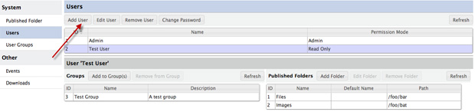

## Editing Permissions & Adding Users

Mollify allows you to edit the permissions of a file without having to access a administrator panel. Each file preview window has a link to edit permissions, where you can make the file read only or grant full access to users. Talking about users, options to create *users* and *usergroups* are available in the same window as well.