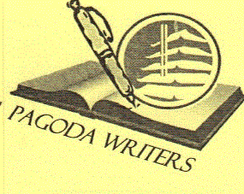

Pagoda Writers

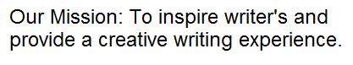Open To All

Creative and Fun Workshop

**1st Saturday each month 1:00 to 3:00 pm  
(weather and road conditions permitting)**

At the Pagoda 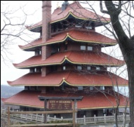 on Mt. Penn.

Call L.T. at 610-413-0373

Upcoming Workshop

**November 2, 2013  
John Yamrus**

**Widely published poet returns to Pagoda Writers and shares his secrets for writing works that are both funny and concise. His work has been described by the great Milner Place as “...*a blade made from smooth honest steel, with the sharpest of edges*.”**