

Pagoda Writers

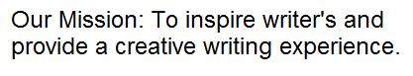Open To All

Creative and Fun Workshop

**1st Saturday each month 1:00 to 3:00 pm  
(weather and road conditions permitting)**

At the Pagoda 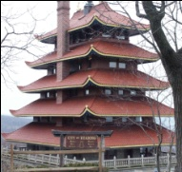 on Mt. Penn.

Call L.T. at 610-413-0373

Upcoming Workshop

**To Be Determined  
watch This Space**