

Pagoda Writers

Open To All

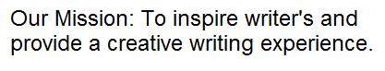Creative and Fun Workshop

**October 15   
from 12:30 pm to 3:00**

Paris at the Pagoda

Mentally, in Paris 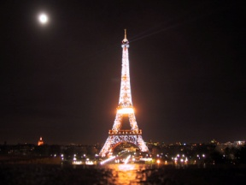. Come join us for brainstorming on 2012 workshops,   
open readings, artists, writers, and poets coming together inspired by early 20th century in Paris, France.

but physically 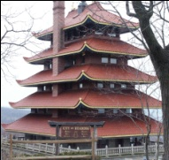 on Mt. Penn.

Call L.T. at 610-413-0373