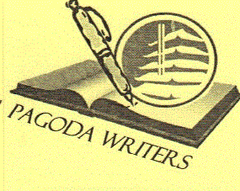

Pagoda Writer's

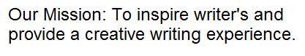Open To All

Creative and Fun Workshop

**1st Saturday each month 1:00 to 2:00 pm  
(weather and road conditions permitting)**

At the Pagoda 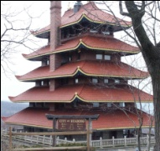 on Mt. Penn.  
98 Duryea Dr., Reading, PA

Call L.T. at 610-413-0373

Upcoming Workshop

CJ Rhoads   
(Successful Author, Editor, & Publisher)

Moving from Creative Writing to Professional Writing

Saturday December 3, 2011 at 1:00