# Wikipedia Editing Notes:

*(quick notes by CJ Rhoads to help people get started. Friday, July 27, 2012)*

## Need a login

Although I think there is a way to make edits to a wikipedia page without logging in, your edits are much more likely to be accepted if you have a login. No one likes anonymous edits. Plus, you get all the menus which will let you see what you've edited already. Additionally, having a login allows you to document why you made the edit, and, if necessary, engage in discussion in the Talk section if you think the edits might be controversial.

## Review History

Under the Context menu you will see a **Page History** choice. It's usually a good idea to review the history before making edits; you don't want to start editing until you get a feel for what other people who review the page are thinking. Remember that no one is in charge - it's up to everyone to agree to what's been posted (which basically means leaving it alone and not changing it).

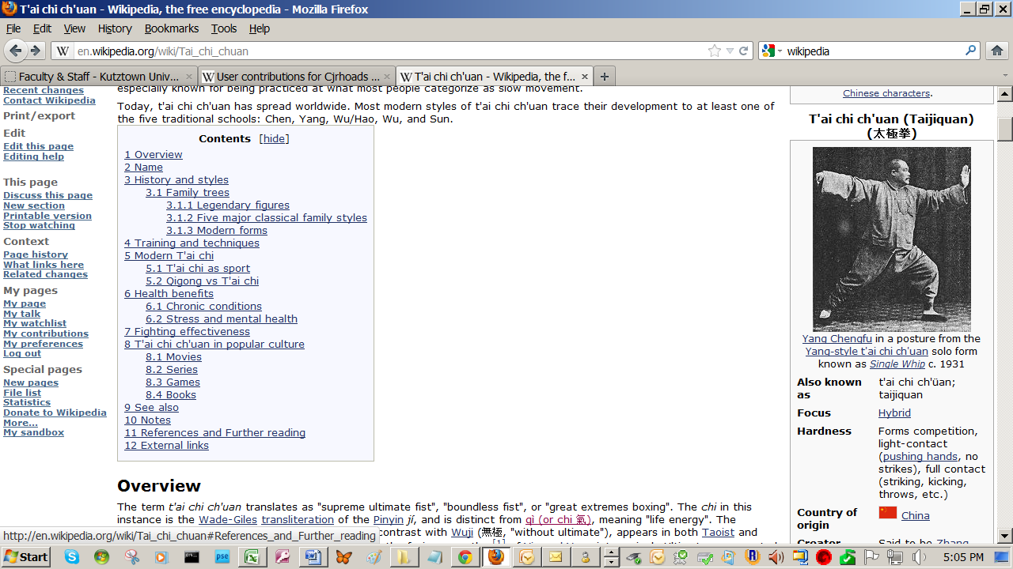

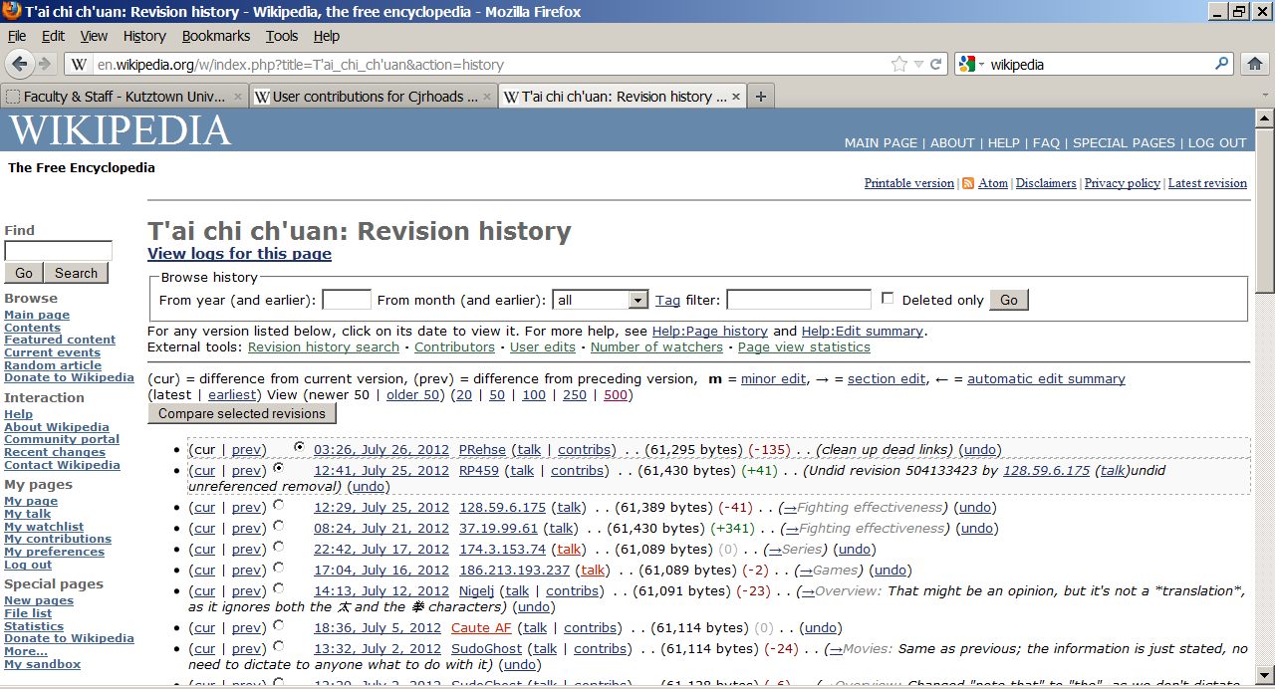

## Set Up Your Watchlist

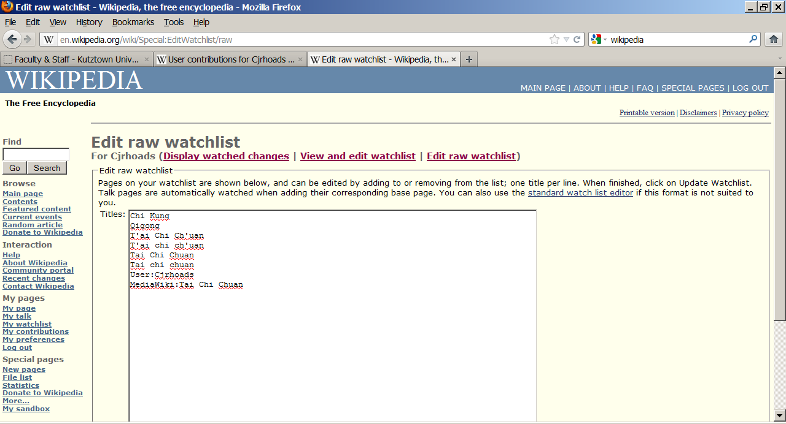After you've created all the pages you wish to create, you might want to put them on your watchlist so that if other people change them, you know who changed it and why.