CJ Rhoads: A Biography
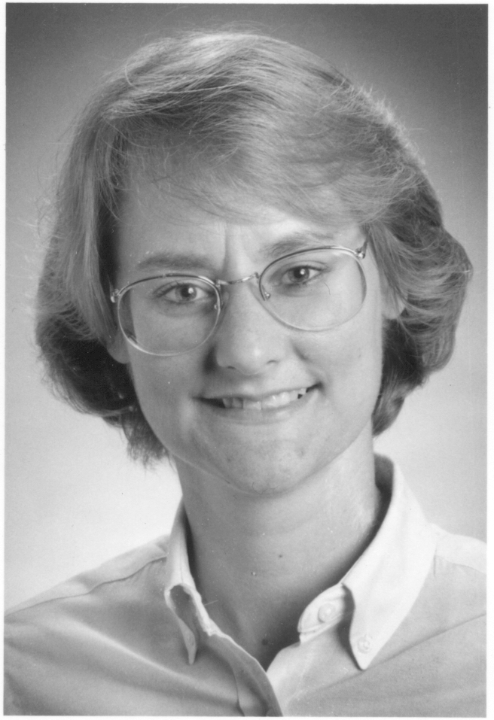Dr. Christine Judith Rhoads (“CJ”) is President and CEO for ETM Associates, Inc., a consulting firm specializing in enterprise leadership and technology management issues. Rhoads is a dynamic speaker and flourishing author. She written five books including the bestseller The Entrepreneur's Guide to Managing Information Technology and is the editor for The Entrepreneur’s Guide series for Praeger Publishing. Her research in leadership and strategy is well-known for its practical usefulness. More than a hundred and fifty of her articles have been published over the past five years, many reprinted and translated into several different languages. Her current focus is to identify the best ways for businesses to survive and thrive through the recession, which she predicted in a published article in March of 2008.
Rhoads developed her extensive knowledge through a combination of startups and Fortune 500 companies in the financial industry. Prior to starting ETM Associates, she served as Chief Technology and Operations Officer for CommerceLinks.Net, a startup specializing in Live Video Customer Service technologies where she designed and wrote a patent for the technology. During the height of the Internet bubble she utilized her talents as Chief Technology Officer of Millstar, an E-commerce software development company specializing in on-line catalogs of highly complex product sets for click and mortar companies. Her large company experience was garnered previously as Vice President of First USA/Bank One and MBNA/Bank of America where she provided internal consulting to senior management on decision making and technology project management. For the past few years her clients have been smaller technology firms where she provides leadership and strategic guidance, or larger Fortune 500 companies where she provides needed help in managing information technology issues. In 2009 she was named one of Pennsylvania's Best 50 Women in Business by Governor Rendell's office, and in 2011 the Greater Reading Chamber of Commerce awarded her the coveted Athena Award.
She currently sits on the Boards of Directors of CTCE Federal Credit Union. In the past she has served on dozens of Boards of non-profit and trade organizations including Association for Technology Professionals, Women in Technology International, Cambridge Information Network, Chief Officer.com, Pacem in Terris, and Project REACH.
Rhoads is also an Associate Professor in the College of Business at Kutztown University, where she teaches graduate courses in entrepreneurship and project management, and undergraduate courses in business technology. She has been named a Sam M. Walton Free Enterprise Fellow for SIFE, an entrepreneurial student club, and was awarded the John P. Shellenberg award for Excellence in Teaching. She also is the volunteer managing director for Pacem In Vita Institute, a 501c3 non-profit dedicated to spreading the benefits of integrative health practices to everyone.
Rhoads has a Doctorate in Educational Technology from Lehigh University with a minor in Business Administration, and a Master's degree from Temple University in Educational Psychology with a focus on Instructional Design.
Rhoads started her career by building Computer Educational Services, a highly successful computer training and consulting firm which she profitably sold and which eventually merged into Verso Technologies, a publicly traded company.
Personally, she enjoys practicing Taijiquan (a Chinese martial art), hiking, bike riding, golfing, swimming, and reading science fiction. In 2009 she was a Gold Medalist and National Champion in the Women’s Push Hands division for the International Chinese Martial Arts Championship in Washington DC, and in 2010 she was named to the Fellowship of Martial Artists Hall of Fame as Taijiquan Event Promoter of the Year. She lives in Yellow House, PA with her husband of 25 years.

