World War II Folk Art Map
16th Armored Division’s Liberation of
Pilsen, Czechoslovakia -- May, 1945
----------------
John M. Lawlor, Jr.
June 6, 2015

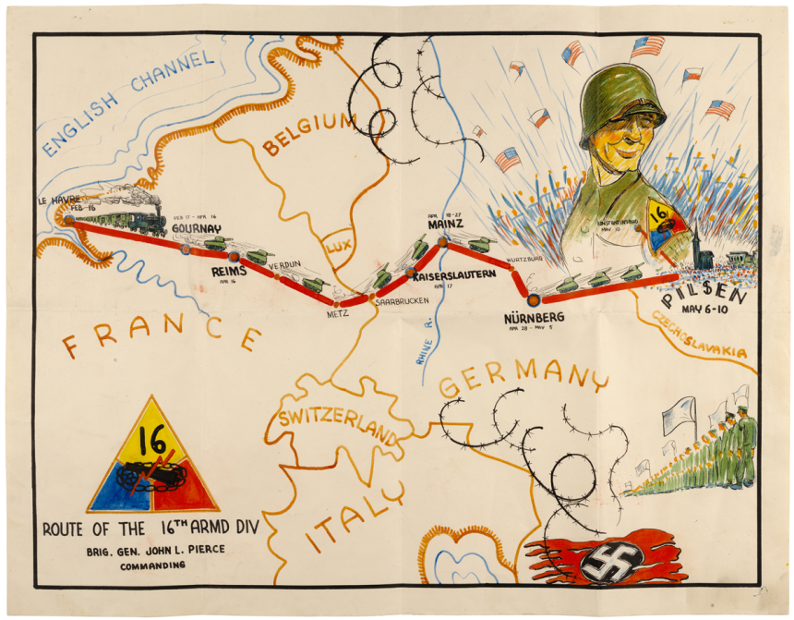

This study serves to assess the accuracy of a rhetorical folk art map found among the records of the U.S. Army’s 16th Armored Division. The map, folded up and tucked away within one of thousands of World War II archival boxes at the National Archives, is a visual record that recounts the unit’s activities during the war.
Subsequent to the discovery of the map, additional research at the National Archives in College Park, MD, confirmed that accuracy of the map using a combination of documents, photographs and historical film footage. Each symbolic element on the map is supported by historical evidence. These include passage of the unit through Europe, surrender of Nazi troops and capture of their flag, and the liberation of Pilsen with film of street combat and celebrating civilians.
The presentation deploys multimedia to connect elements on the map to the appropriate media objects.
The presentation explains the discovery of the map, its central role in an essay competition at the National Archives, and the research process that confirmed its accuracy. John M. Lawlor, Sr., the presenter‘s father, was one of the 15,000+ soldiers in the 16th AD who participated in the liberation of Pilsen.

